•  **Course Outcome to be covered: CO1:**Merits of digital systems, various number systems and their applications.

**Lecture Outcomes:** Students will be able to know about regarding different of digital and applications

• **Analog Vs Digital System**

* Analog and Digital signals are the types of signals carrying information. The major difference between both signals is that the analog signals that have a continuous electrical, while digital signals non-continuous electrical. The difference between analog and digital signal can be observed with the various examples of different types of waves.

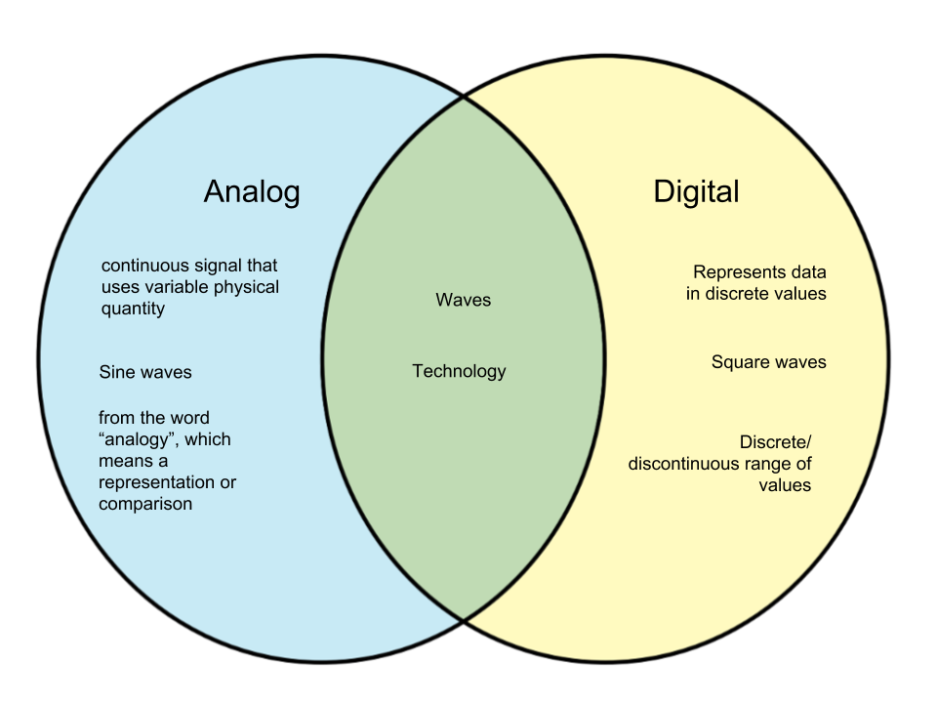

Fig [1.5]: Venn diagram showing difference between Analog & Digital

* In analog technology,a wave is recorded or used in its original form. So, for example,in an analog tape recorder, a signal is taken straight from the microphone and laid onto tape. In digital technology, the analog wave is sampled at some interval, and then turned into numbers that are stored in the digital device.

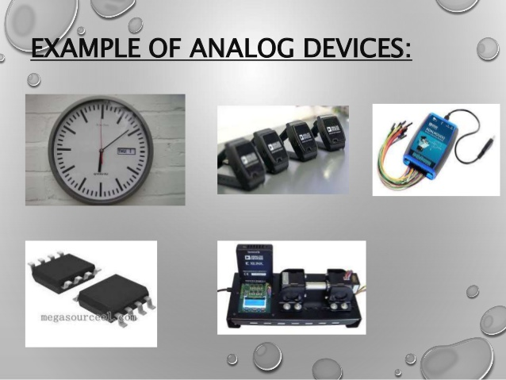

Fig.[1.6]: Examples of Analog Devices

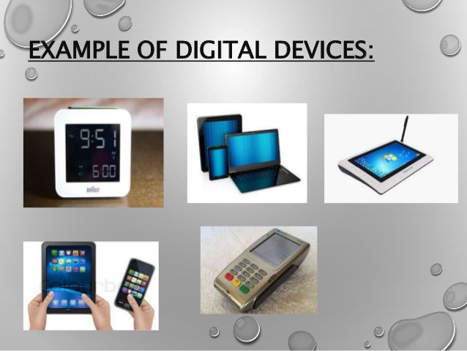

Fig.[1.7]: Examples of Digital Devices

**Key Parameters Differences between Analog and Digital Communication**

* **Bandwidth:** This factor creates the key difference between Analog and digital communication. Analog signal requires less bandwidth for the transmission while digital signal requires more bandwidth for the transmission.
* **Power Requirement:** Power requirement in case of digital communication is less a compared to Analog communication. Since the bandwidth requirement in digital systems is more thus, they consume less power. And Analog communication system requires less bandwidth thus more power.
* **Fidelity:** Fidelity is a factor which creates a crucial difference between Analog and digital communication. Fidelity is the ability of the receiver which receives the output exactly in coherence with that of transmitted input. Digital communication offers more fidelity as compared to Analog Communication.
* **Hardware Flexibility:** The hardware of analog communication system is not as flexible as digital communication. The equipment used in digital technology are compact in size and consumes less power.
* **Error Rate:** Error rate is another significant difference which separates Analog and Digital Communication. In Analog instruments, there is an error due to parallax or other kinds of observational method.
* **Synchronization:** Digital communication system offers to synchronize which is not effective in analog communication. Thus, synchronization also creates a key difference between Analog and Digital Communication.
* **Cost:** Digital communication equipment are costly and digital signal require more bandwidth for transmission.

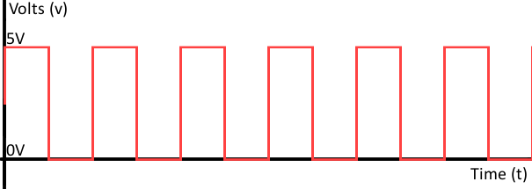

Fig [1.8]: Digital signal Comprises of only two values High by 1 bit(5V) & Low by 0 bit(0V)

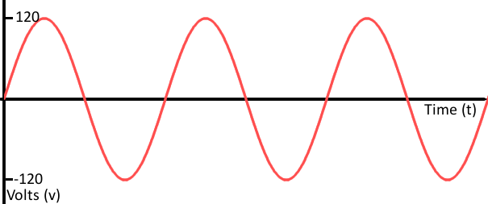

Fig. [1.9]: Analog Signal comprises of infinite values between given limits

**Conclusion**

* Analog communication is entirely the use of continuous time varying signal for the transmission of information from the sender to receiver. On the other hand,digital communication utilizes the usage of digital technology for sending the information over the channel.
* Analog communication is becoming obsolete in contemporary times with the advent of digital technology. The drawback of using digital communication is that it requires more bandwidth for transmission which makes it costly. Thus, if cost is not the issue we can use digital communication for our purpose, but if we need an economical system then choose Analog.

**Application of Digital Electronics (Real Life Application)**

Digital systems are designed to store, process, and communicate information in digital form. They are found in a wide range of applications, including process control, communication systems, digital instruments, and consumer products.A computer manipulates information in digital, or more precisely, binary form.Digital electronics includes many applications in real life. **Here are three different and most important application of Digital Electronics.**

* Simple combination lock: This is a simple but effective code lock circuit that has an automatic reset facility. Using XOR gates as bit comparator Build simple gate functions with diodes and a pull up/down resistor Using NOR gates as controlled inverters.

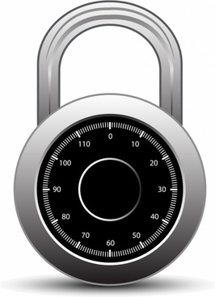

Fig. [1.9] Digital Combinational lock

* A Digital Stopwatch: A digital stopwatch circuit can be worked as a clock in this counter will advance after every one second. The circuit operation begins once open switch is changed to closed position.

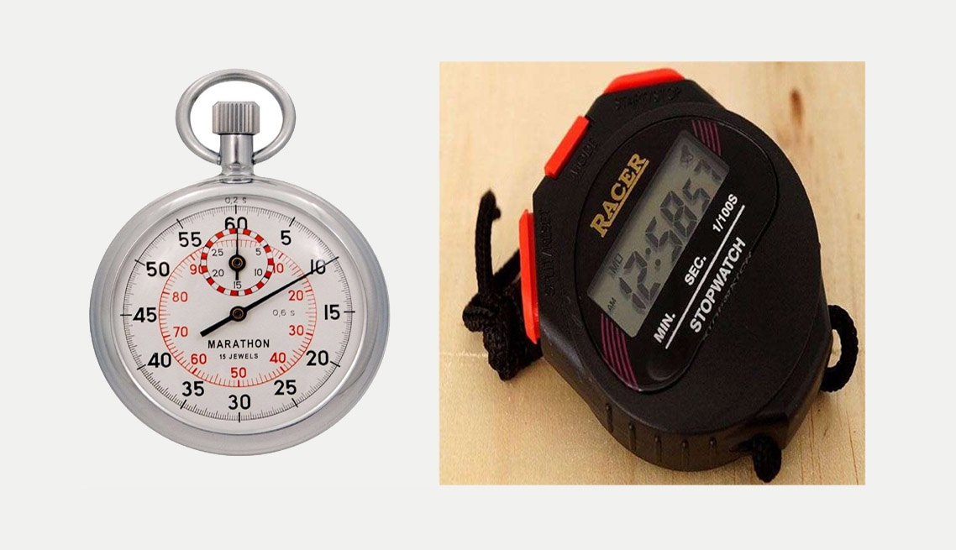

Fig.[1.10] : Digital Stopwatches

* Smart Card: It contains an integrated circuit chip,microprocessor with memory exchange, store the data and manipulate data. Areas of Smart Card Applications includes telecommunications, domestic, e-commerce and retail, banking application,Government Applications and Secured Physical access.

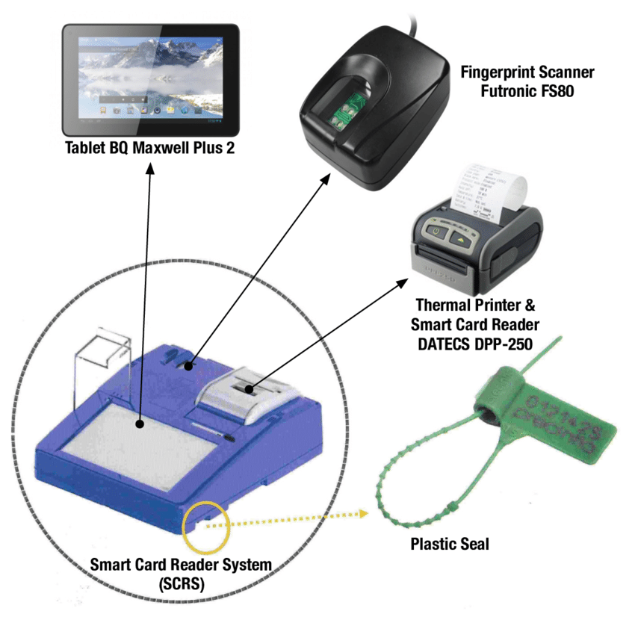

Fig.[1.11]: Smart Card Reader

**Conclusion**

1. It is therefore essential for engineers and students to understand the fundamentals, implementation and application principles of digital electronics, devices and integrated circuits. This is so that they can use the most appropriate and effective technique to suit their technical need.

• **Book:**

[**https://www.flipkart.com/analog-digital-electronics/p/itm862769537faf7**](https://www.flipkart.com/analog-digital-electronics/p/itm862769537faf7)

Analog & Digital Electronics by Chattopadhyay D –Flipkart link

[**https://www.amazon.in/Electronics-Analog-Digital-Nagrath-I-J/dp/8120348028**](https://www.amazon.in/Electronics-Analog-Digital-Nagrath-I-J/dp/8120348028)

Electronics: Analog and Digital by Nagrath I.J-Amazon link

**Lecture Notes:**

[**http://www.cse.iitm.ac.in/~vplab/courses/ST/BASICS+NUMBERS.pdf**](http://www.cse.iitm.ac.in/~vplab/courses/ST/BASICS+NUMBERS.pdf)

**Video Lecture:**

[**https://nptel.ac.in/courses/117/106/117106086/**](https://nptel.ac.in/courses/117/106/117106086/)